April 20, 2015

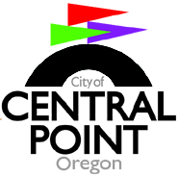
2015/2017 Biennial Budget
Meeting/Agenda #2

Time: 5:20 pm - Please join us for dinner

Place: Council Chambers, 140 South Third St., Central Point, Oregon
--------------------------------------------------------------------------------------------

6:oo pm: Meeting called to order/roll call

Presentations:

      - Technical Services

      - Community Development: Planning/Building

      - Public Works: Street/ Water/Stormwater/CIP

      - Internal Services: PW Administration/ Fleet/Facilities

Call for motions

Announce CP Development budget meeting #3

Meeting adjourned

Note: If you have any questions regarding this information or cannot attend, please give me a call at 541.423.1023. Thank you, Bev Adams

