April 29, 2019

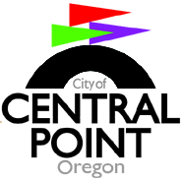
2019/2021 Biennial Budget
Meeting/Agenda #1

Welcome to the first 2019/2021 biennial budget meeting.

We are pleased to have your participation, and sincerely appreciate your assistance with perhaps the single most significant process in preparing for a successful future.

Time: 5:50 pm - Please join us for dinner

Place: Council Chambers, 140 South Third St., Central Point, Oregon
--------------------------------------------------------------------------------------------

6:3o pm: Meeting called to order
Roll Call & Call for Nomination of Budget Chair & Secretary:

Budget message & general overview

Presentations:

      - Administration/Mayor & Council

      - General Fund Revenues/Public Hearing #1

      - Finance/GF Intergovernmental/Reserve

      - Public Works/Parks & Recreation

      - Internal Services: PW Administration/Fleet/Facilties

      - Debt Service

Call for motions

Announce budget meeting #2

Meeting adjourned

